Rural Community Energy Fund guidance:
applying for a Stage 1 feasibility grant

Background
The Rural Community Energy Fund (RCEF) is being delivered by the five Local Energy Hubs in England on behalf of the Department for Business, Energy & Industrial Strategy (BEIS) and the Department for Environment, Food and Rural Affairs (Defra). It provides non-capital grant funding over two stages to help community organisations with the development of a renewable energy project.

The aims of the fund are to:

- Increase the level of community and locally owned renewable energy generation to support the Government’s goal of achieving net-zero carbon emissions by 2050;
- Support rural communities by helping them to reduce energy costs or generate income from renewable energy and reinvest this income in the local area, and
- Promote rural growth through the creation of jobs and volunteering opportunities in the communities where projects are located.

The Fund will achieve its aims by removing the barriers to investment, which are currently preventing the development of community scale projects. These include the up-front costs associated with providing evidence of technical feasibility, designing a scheme and gaining planning permission, the finance for which is not readily available in the commercial market. RCEF has been designed to provide that funding to community organisations to establish the feasibility of a renewable energy project and develop the business plan.

RCEF – stage 1 or 2 support

Stage 1 – Feasibility Grant
For communities at an early stage of exploring a specific renewable energy project that meets the RCEF eligibility criteria, grants of up to £40,000 are available to cover consultancy and professional costs for producing an initial feasibility report in a standardised format.

Stage 2 – Full Business Planning Grant
For projects with proven feasibility that can demonstrate a good chance of securing planning permission and being implemented, further development funding of up to £100,000 is available. This funding is to cover costs that include securing a site (legal fees for example), environmental impact assessments, submitting planning applications, permitting applications and developing a full investment business plan.

NB: This guidance is for applications for Stage 1 Feasibility Grants. If your project is further along in its development, you may wish to apply directly for Stage 2 grant funding. Please contact your Local Energy hub to confirm.

Introduction
RCEF Stage 1 funding is for community groups that are ready to procure the professional services needed to produce a feasibility report for their local energy project. The grant is dependent on a number of criteria that are set out in this guidance, but it is important to note that the project must-be community-led and that some initial work will need to have been carried out before an application can be submitted.

The dedicated RCEF Officer within your Local Energy Hub will be able to help develop your proposal and assist you with completing the application. They will be able to assist you help you think through your objectives, outcomes and risks which can be difficult to do. The contact details for your Local Energy Hub Officer are at the end of this document.

Application forms should be fully completed and emailed to your Local Energy Hub Contact with all supporting documents. Grant applications are considered on a quarterly basis and funding decisions will typically be communicated three weeks after they have been considered by the Local Energy Hub Board.

If you are unsure of which Energy Hub you should contact, please refer to the guidance in Annex 1.

Eligibility requirements

The following are the basic criteria that all applications must meet at the outset in order to be eligible for RCEF support (note that there are a number of actions that you will need to have taken in order for your application to qualify)

Projects must be based in a rural community
Funding support is available to rural community organisations in England. Defra’s Magic Map will show you whether the postcode of your project location is based within a rural area. Please see Annex 2 for a short visual guide on how to use the Magic Map for this specific purpose.

Applications from organisations located in a different geographical location from that of the infrastructure to be developed will still be considered, provided they can demonstrate the support of the community in proximity to where the infrastructure will be located and how the income and benefits generated will flow to that community.

- Applicants must be a qualifying community organisation
In order to receive funds, a local community group must have formed a legal entity which provides a benefit to the community. For the purposes of RCEF, this includes:
- Community Interest Companies (CICs)  - Community Benefit Societies (Bencoms)  - Co-operatives  - Pre-commencement societies  - Registered Social Landlords | - Charitable Incorporated Organisations (CIOs)  - Registered Charities  - Development Trusts  - Amateur sports associations  - Town or Parish councils
There are instances where groups can work with others to realise their project. For instance, although local authorities are not eligible for RCEF by themselves, they can support or partner community groups who wish to apply.

Applications for joint ventures (i.e. where a group has partnered with a business to realise the project) will be considered on a case-by-case basis. To be eligible for support the community organisation must be the lead partner and own at least 50% of the project.

Project must be community-led
Whilst you are free to work with other partners in order to realise your project, funding will only be provided for projects that are at least 50% owned by the community. Further, the project must be driven by your community group – proposals that originate from private sector companies or consultants are not eligible for support.

Project must be based on eligible technologies
Below are example technologies which are eligible for support under RCEF given their ability to reduce carbon emissions:

- Solar photovoltaic  - Solar thermal  - Anaerobic digestion  - Wind turbines  - Multi-technology approaches | - Heat pumps (air, ground and water-source)  - heat networks (renewable fuels only)  - Hydropower  - Bioliquids/gas/fuels
Note that multi-technology approaches can include energy efficiency, battery storage, electric vehicle infrastructure, grid services and demand side management. Such projects will be considered on a case-by-case basis.

Please note the following are not eligible for support:

- Any technology that runs on fossil fuels
- Any technology that may provide extra community benefit (for example through increased income) but will not by themselves directly add to the reduction of carbon emissions e.g. projects to connect a private wire between two existing facilities

It may be the case that you will have been unable to determine the optimum technology for your project when you apply to RCEF. You may use a small part of the grant to do this, but the majority of the funding must be utilised in developing a project with an identified technology at site. Applications will not be accepted that are simply a review (i.e. a scoping study) of possible options.

Project must be of sufficient size or complexity
The scale of projects eligible for funding will vary according to the chosen technology type. In general terms your project should meet one of the following criteria:

- Require planning permission and significant pre-planning development
- Generate energy for multiple buildings (or export the equivalent to the grid).
- Applications for installations on multiple individual community buildings as part of one project will be accepted and reviewed on a case by case basis
- Single community buildings are eligible for RCEF if they are exporting the equivalent back to the grid, though the funds generated from this must be used for wider community benefit.
- We will also consider single buildings that generate their own energy and export excess to other buildings e.g. in the case of heat networks.
- Single buildings that generate energy purely for their own consumption, with no export back to the grid, will not be eligible unless their remote location means this is not feasible and the options for redevelopment are restricted. Such applications will be reviewed on a case by case basis.

Project must have a clear community benefit
A key aspect of RCEF is that the wider community should benefit from having the project based within it. It is therefore expected that the income that is expected from the final project – whether from energy generation or savings from reduced energy costs – should be passed to the wider community itself.

The reductions of bills for host sites will be considered enough of a community benefit by itself when the scheme is wholly owned by the community and the community is liable for the decommissioning of any plant built.

Projects where only a section of the community will benefit (e.g. where the project would provide energy savings or income to a small number of households) are only allowable when any profit generated by the scheme will be placed in a community benefit pot and that fund will have a governance to ensure that it supports the local community. The community should be able to report on how much was in the pot every year and what it has been spent on.

Note that for any joint ventures clearly separate the community inputs and outputs from those of the commercial partner.

Applicants must meet requirements on EU State aid
State aid is any support given by Government that gives a selective advantage (via grant, tax break, etc.) to any entity, regardless of legal form, that undertakes economic activity. Because such support comes with the risk of distorting market competition its use is tightly controlled. As the grant funds under RCEF are given by the Government to community organisations that are engaged in an economic activity i.e. the generation of energy, this support is deemed to be State aid and must be given using a route that is allowable under EU rules.
RCEF normally uses the ‘de minimis’ regulation which is the simplest route. It is the European Commission’s view that small amounts of aid are unlikely to distort competition, so it allows sums of less than €200,000 in total to be given to organisations over three fiscal years. This €200,000 limit is known as the de minimis allowance.
It is important to note that the de minimis allowance is for the receiving organisation, not the project. As an example, if Organisation A secured £100,000 of RCEF funding for feasibility of a large hydro project and immediately afterwards received £150,000 from another public body which was also granted as de minimis aid, this would exceed the Organisation A's allowance.
Any de minimis State aid from a public body in the last three fiscal years counts towards an organisation’s limit. As these three years are rolling, an organisation applying for de minimis aid must look back over the previous 36 months to see what de minimis aid has already been received.
Applicant organisations are required to declare all public funding received during the previous three years and specify how much of this was de minimis aid received during the previous three fiscal years. This information should be sent using the De Minimis Declaration Form which must be signed and submitted as part of your RCEF grant application.
Please note that applicants must keep records of all de minimis aid paid out to them for ten years from the last payment. Beneficiaries must keep records of any de minimis aid received for three years and declare this when required to do so by other grant giving bodies. The de minimis regulation itself can be read here.

What can be funded for the feasibility report
Stage 1 funding is intended to be used to secure the professional services needed to produce a comprehensive feasibility study covering all aspects of your project. Section 1.6 of the application form details the types of professional support that are eligible to be funded.

The supporting document Stage 1 Feasibility Report Structure sets out all the questions that need to be addressed within the report, though these cover all types of project so not all will be relevant to yours.

In general, when considering what activities you need consultants to undertake, the completed feasibility study should have met the following objectives:

- Technical feasibility will have been done to a reasonable level i.e. the work should be proportional to the technology, scale and site chosen.
- Potential grid connection issues will be understood
- Some community consultation will have been carried out
- A legal agreement for your use of the site will have been established with the landowner
- Potential planning issues for the site will be understood
- An outline business plan for the next stages of the project, costs and activities that may be supported by a development grant will have been developed.

Carrying out work in-house
If your community organisation has members qualified to undertake any of the activities and are requesting grant funds towards this, there are a number of criteria that must be met:

- If you intend to undertake the technical consultancy yourself, then two external quotes will need to be provided whilst you will need to comply with the criteria applicable to other service providers on experience.
- If you intend to undertake project management and general admin duties as part of any feasibility study, we expect these to be restricted to 10% of the overall costs claimed.
- The funding cannot be used to cover the salaries of existing paid members of staff who could be expected to work on the project in their normal line of work
- If you have developed several closely related projects (i.e. the same application of a given technology in a different location) you will be expected to demonstrate cost efficiencies due to the replication of work undertaken previously and any lessons learned.

Claiming for VAT
You may be required to pay VAT on purchases you make as part of your project. You must only include VAT in the amount you request from us if you cannot claim it back from HM Revenue and Customs. If you later find that you can recover the VAT that we have included in our grant, these funds will need to be returned to us.

Actions to be completed before submitting your application

There are several requirements that your project will need to have met before you submit your application for a grant. These are listed below.

Undertake initial community engagement
Applicants must be able to demonstrate that some initial community engagement has been carried out and that there is no obvious objection for the project. This can be done by surveys or other forms of public engagement. This support can be critical for obtaining planning permission and in raising funds and attracting a customer base, depending on your financial model.

provide a record of contractor procurement
Please note you are required to have sent the Stage 1 Feasibility Report Structure document to contractors along with the project brief when you initially go out to tender.

You will need to send us the project brief that you sent out to consultants along with the quotes you received in return. A minimum of three quotations is expected for all services with a value of over £5,000 (if the value is lower you will be expected to have attempted to obtain three quotes before awarding the contract).

You’re chosen contractor should represent the best value for money. You should be prepared to submit evidence as how you have come to your decision, particularly when you are undertaking work in-house.

You will also need to ensure the service provider you have chosen to carry out the feasibility work has the appropriate skills and experience. The Local Energy Hubs reserve the right to decline an application if it is considered that the service provider does not have the appropriate skills and experience to undertake the work, or if their proposal does not adequately cover all aspects of the Feasibility Report Structure. We will look for:

- A comprehensive proposal covering all aspects of the Feasibility Report Structure.
- A demonstrable track record of experience and/or qualifications in the relevant field. This may be demonstrated by their professional accreditation, CV, case studies, testimonials etc. This will include having appropriate financial experience if required to put together financial plans for the project
- Professional indemnity insurance of over £1m to cover your community for the investment of time and money you will be making based on their advice.
- Value for money, given that the grant award falls under the remit of public funds

The selection of contractors must be undertaken through a transparent procurement process. Potential contractors must not be involved in the development of tender documents or the collation, evaluation and selection of proposals or have access to proposals from other bidders.

We will need to know whether your selected contractor(s) has/have any personal or business relationships, for example with your community organisation or technology supplier, which might influence their advice.

Agree to obligations on knowledge sharing
RCEF funding projects must share outcomes and findings to benefit local energy generation in England. To facilitate knowledge sharing that has the potential to support the wider sector, information resources developed whilst undertaking the project will be hosted on the Community Energy England website and branded accordingly. The applicant organisation(s) will also be credited for their work.

Any intellectual property (IP) must be shared with the Local Energy Hub and BEIS. All partners and contractors involved in the project must agree with this obligation. All materials produced or events delivered must adequately acknowledge the assistance of RCEF.

Application Process
If you are considering an application or have a general enquiry you should contact your Local Energy Hub. The RCEF Project Officer and/or Energy Hub Project Managers can provide support to help you develop your application. Note that groups that have not contacted their Local Energy Hub prior to submitting their application cannot be considered for funding.

Application forms
Application forms should be fully completed. A Word version along with supporting documents should be emailed to your Local Energy Hub. Any applications considered by the Local Energy Hub to be incomplete, of insufficient quality, unclear in aims or that are considered to have not met the RCEF objectives will be rejected.

Please see Annex 3 for a checklist on the documents that need to be sent with your application

Application assessment
Following the close of the application round window, your application will be reviews by a funding panel comprising members of the relevant Energy Hub board. The Local Energy Hubs reserve the right to consult with each other and take independent advice from experts where appropriate.

Applicants will be informed of the outcome of applications within three weeks of the funding panel meeting. The decision of the funding panel is final and there is no right of appeal on any funding decision. You will be provided with feedback on your application and could be invited to re-apply.

Any funding award will be made subject to your acceptance of the funding terms and conditions. Please note that the terms are non-negotiable.

Grant payments
Grant funding is released against stages of work, rather than a lump sum on the application being approved. Funds may be claimed in advance of expenditure for each stage of work, however further funds will not be released until satisfactory completion of the tasks for that stage.

A RCEF claim form will be issued with your offer letter. For each stage of work you will be expected to complete and submit a RCEF claim form to your Local Energy Hub. Each Claim Form should be accompanied with evidence or copies of work undertaken and receipted invoices. Claims will be processed within ten working days of receipt of the completed claim being received by your Local Energy Hub.

Grant payments will be transferred to your account via BACs once we receive your signed RCEF claim form and have completed our checks. This process may vary between the Local Energy Hubs. Please note that monthly updates and spend forecasts will also be required and sent to the relevant Local Energy Hub.

Important: On completion of your project we will require you to submit your feasibility report to the Local Energy Hub for review prior to making the final payment to your contractor. Evidence of all expenditure such as invoices, receipts and proof of payment are also required. Should you have any grant funds remaining on completion of your project these must be returned to the Local Energy Hub.

Verifying bank details
We require grant recipients to have their own UK-based bank account. There will need to be two authorised signatories on the account for all cheques and withdrawals, including internet purchases. The account signatories must not be related or live at the same address.

In order to verify your account details we will require you to provide an original bank statement with all pages included that is no more than three months old. If you are a new organisation that has only recently opened an account, we will require you to obtain a letter from your bank confirming when the account was opened, your account details and the names/addresses of the account signatories.

NB: We require original documents for this purpose. On completion of our checks your documents will be returned to you via secured post. If you are unable to provide original documents, we will require copies that must be stamped and certified as true copies by your Bank or Building Society.

Upon completion of our final checks we will notify you of when you may proceed with the project.

Local Energy Hub Contact Details
If you would like to apply for RCEF, or have any queries, please contact the relevant Local Energy Hub for your area for more information.

North East, Yorkshire and Humber | rcef@teesvalley-ca.gov.uk
North West | team@localenergynw.org
Midlands | michael.gallagher@nottinghamcity.gov.uk
South West | swenergyhub@westofengland-ca.gov.uk
Greater South East | info@energyhub.org.uk

Annex 1: Identifying your local Energy Hub

The Local Energy Hubs are split into Local Enterprise Partnership (LEP) regions. You can check which LEP your local authority is in by referring to the spreadsheet here, then check the below to see which Hub covers that LEP:

North East, Yorkshire and Humber
- Tees Valley Combined Authority LEP | - Humber Local Enterprise Partnership
- North East LEP | - Sheffield City Region LEP
- Leeds City Region Enterprise Partnership | - York, North Yorkshire and East Riding Enterprise Partnership

North West
- Cumbria Local Enterprise Partnership | - Cheshire and Warrington LEP
- Greater Manchester LEP | - Lancashire Enterprise Partnership
- Liverpool City Region LEP

Midlands
- D2N2 (Derby, Derbyshire, Nottingham, Nottinghamshire) LEP | - Stoke-on-Trent and Staffordshire Enterprise Partnership
- The Marches Local Enterprise Partnership | - LLEP (Leicester and Leicestershire Enterprise Partnership)
- Worcestershire LEP | - Black Country LEP
- Coventry and Warwickshire LEP | - Greater Birmingham and Solihull LEP
- Greater Lincolnshire LEP

South West
- Swindon and Wiltshire LEP | - Heart of the South West LEP
- West of England Combined Authority | - Cornwall and Isles of Scilly LEP
- GFirst (Gloucestershire) LEP | - Dorset LEP
- Solent LEP

Greater South East
- Cambridgeshire and Peterborough Combined Authority | - New Anglia Local Enterprise Partnership
- Herts (Hertfordshire) LEP | - Buckinghamshire Thames Valley LEP
- OxLEP (Oxfordshire) LEP | - SEMLEP (South East Midlands LEP)
- Coast to Capital LEP | - South East Local Enterprise Partnership
- Enterprise M3 LEP | - Thames Valley Berkshire LEP
- LEAP (London Economic Action Partnership)

Annex 2: Navigating the Magic Map to check RCEF eligibility

The Magic Map can be used to help you determine eligibility for RCEF. The two images below provide guidance on how to do this.

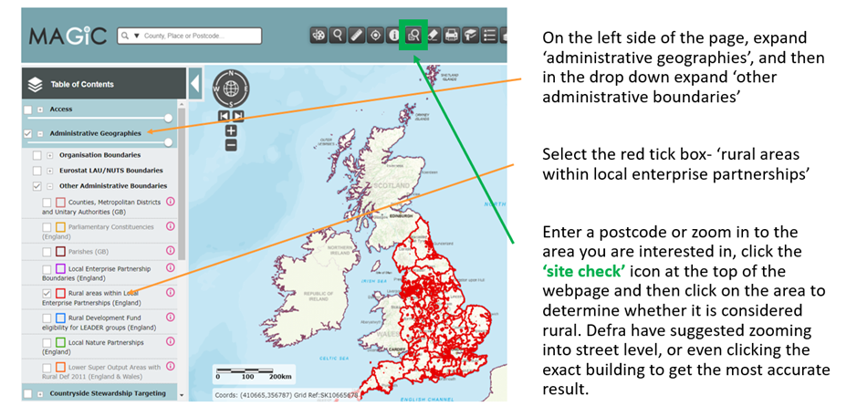

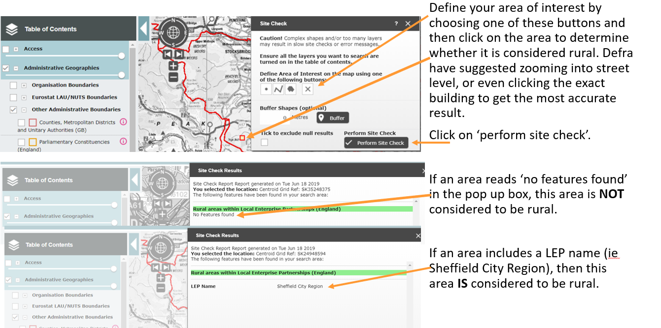

Annex 3: RCEF application checklist

Your application will need to include the following documents along with the application form:

- Your project brief
Please include the invitation to tender or brief that you sent to prospective consultants.

- Quotations
Quotations should be obtained by sending a brief to potential contractors which includes the
Feasibility Report Structure. Delivery of the Feasibility Report Structure should be considered when assessing quotations. Please note we cannot accept applications without quotations, including for any work that you plan to undertake yourselves. We will require you to provide a justification for your selection within your application.

- CV of person(s) you have chosen to deliver feasibility project
You will need to demonstrate that the person(s) you have chosen to deliver the work has the relevant experience (including financial experience) to carry out the feasibility study. We will require a copy of their CV and details of any similar work they have carried out previously.

- De minimis Declaration Form
Applicant organisations are required to declare all public funding received during the previous three years and specify how much of this was de minimis aid received during the previous three fiscal years.

- Governing Document (required for unregulated organisations)
Your governing document sets out in writing how your organisation is structured, what it is set up to do and how it does it. It may be called a number of things, such as a constitution, set of rules or trust deed. We also do not require this from statutory authorities such as parish councils.

- Copy of your Annual Community Interest Report
If you are a registered Community Interest Company, please provide a copy of your most recent
Annual CIC report.

- Financial Accounts
If your organisation has been formed for 12 months or more, please provide a copy of your most recent financial accounts signed by the most senior representative within your organisation or by your accountant or auditor. If your organisation has been formed within the last 12 months, please record your current and anticipated income stream(s) in section 2.8 on the application form.

